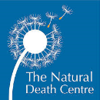


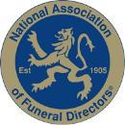

Independent Family
Funeral Directors & Monumental Masons
Associate Funeral Homes in

Bridport, Axminster, Seaton, Honiton & Ottery St. Mary

www.funeraldirectors.uk.com

Matthew Lucas
Down House
Widcombe Street
Poundbury
Dorchester
Dorset
DT1 3BS

01305 753533

www.dorchesterfunerals.com
A Guide To Our Charges

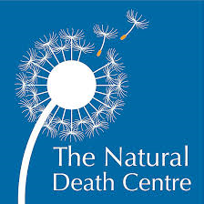


Our Professional Services
Professional Services £1,125.00

- Advice and information regarding Registration of the death.

- The personal attention of the Funeral Director.

- Arranging a date and time for the Service, according to your instructions. We will contact the Church, Cemetery or Crematorium and the officiant who will be conducting the Service, to arrange a mutually convenient date and time.

- Advising on all necessary paperwork and procedures.

- Dealing with all necessary paperwork to enable burial or cremation to take place.

- If required, arranging for catering at a venue of your choice following the Service. (Our Bridport Funeral Home has a function room adjacent to the Service Chapel, where refreshments can be provided by us or yourselves and our Honiton Funeral Home has a large space for refreshments).

- Arranging special musical requests for the Service, such as digital downloads, cds, a soloist piper or choir, as well as ordering music on the digital Crematorium systems, if required.

- Ordering floral tributes on behalf of the family.

- Acceptance and care for floral tributes delivered to our premises prior to the Service and delivery to a local place of your choosing after the Service, if required.

- Accepting donations for nominated charities in lieu of flowers on your behalf, providing a list of those who have donated after the Service and administering funds direct to Charities.

- Collection and care of the Ashes in accordance with your wishes.

- A complimentary online tribute where online donations can be collected through our partnership with Muchloved.

Professional Services £1,125.00
Bringing the person who has died into our care
from a local address or local hospital during normal working hours £295.00
(a supplement charge of £125 will be made outside of these times)
Care of the person who has died before the Funeral £305.00
Chapel visits £47.50
Provision of a Hearse
Local Service followed by a local Burial or Cremation * £765.00
Service at a local Crematorium £765.00
Service at a local Crematorium when additional time booked £890.00

Provision of a Limousine (6 seats)
Local Service followed by a local Burial or Cremation * £325.00
Service at a local Crematorium £325.00
Service at a local Crematorium when additional time booked £365.00
Waiting time for the Limousine (per hour or part thereof) £47.50
* When there is a longer than standard time between the Service
and the Burial or Cremation, 50% extra will be charged
Service in Church (or similar venue) immediately before or after
Burial or Cremation including attendance of Funeral Director & staff £300.00
Attendance of Staff at a Thanksgiving Service (separate occasion) £395.00
Arranging Service Sheets (plus cost of Service Sheets) £45.00
Placing of Newspaper Notices (plus cost of Notice) £45.00
Provision of Embalming (when required) £185.00
Conveyance of the person who has died into a local Church
or address overnight £325.00
Provision of a temporary Grave Marker £50.00
Preparation of an Ashes Grave £95.00
Arranging & attending an Ashes Ceremony £125.00
Collection of Ashes from a local Crematorium (special journey only) £50.00
Additional mileage (if applicable) per mile £2.35
Weekend / Bank Holiday Funerals additional charge from £350.00
Weekend / Bank Holiday Ashes Ceremony additional charge from £125.00
Removal of a Headstone and base from £175.00
Book of Condolence from £45.00
Memory Box from £25.00

If an alternative Hearse is used, an additional vehicle
will be required for the necessary staff £325.00
Our Charges
Weekdays | Attended Service  Standard Fee | Attended Service  Reduced Fee
Weymouth Crematorium | £999.00 | £799  Monday to Thursday 9.30am  15-minute Service - up to 20 mourners  £680  Monday to Thursday 9.00, 9.15 & 9.30am  5-minute Service - up to 20 mourners
East Devon Crematorium  (Whimple) | £1,115  (45 minutes)  10am - 4pm | £875  (20 minutes)  9.30am only
Yeovil Crematorium | £1,100 | 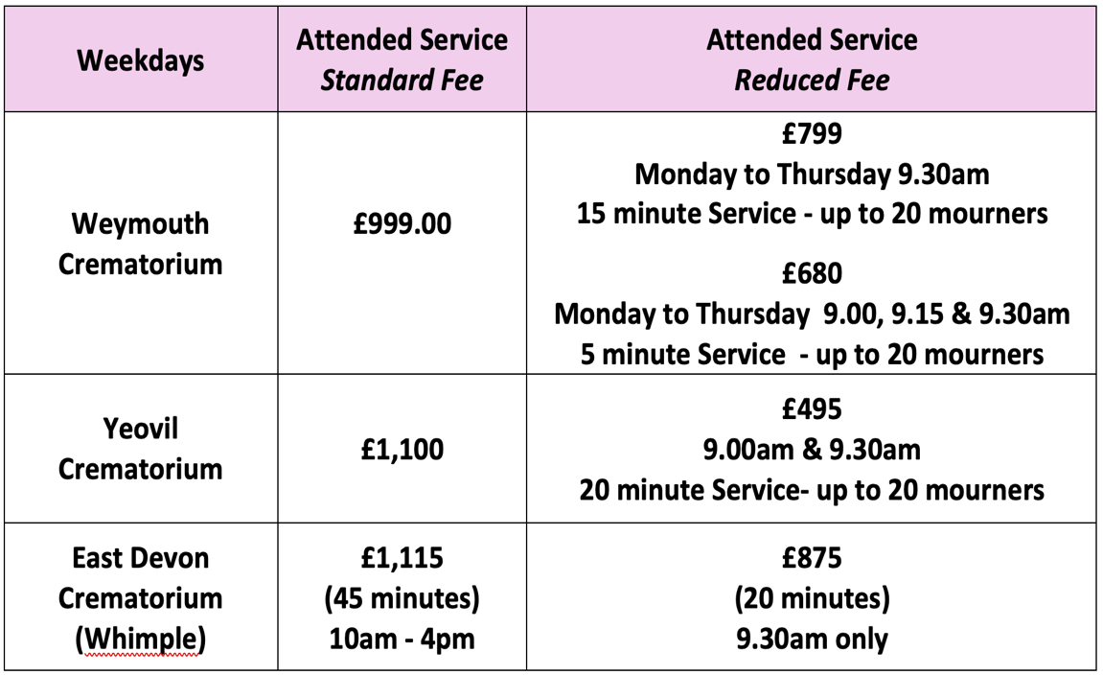  £799  Monday to Thursday 9.30am  15-minute Service - up to 20 mourners  £680  Monday to Thursday 9.00, 9.15 & 9.30am  5-minute Service - up to 20 mourners
Yeovil Crematorium | £1,100 | £495  9.00am & 9.30am  20-minute Service- up to 20 mourners
Disbursements are payments we make on your behalf to third parties and are in addition to our Professional Charges and other fees.
All Disbursements are charged at cost.
Crematorium Fees (Prices correct as at 1st February 2026)

Disbursements

Crematoria have a Digital Music System with many types of music (including organ with and without choir backing) included in their price.
Most Crematoria have screens to show Visual Tributes (photographs and/or videos), Audio or Visual Recording and Webcasting so that a Service can be viewed by those unable to attend. They make an additional charge for the provision of these.

Because the following disbursements vary, an individual price will be given
Minister / Celebrant Church / Venue Cemetery Fees
Churchyard Fees Gravedigger Catering
Newspaper Notices Service Sheets Flowers

The total cost of the Funeral Director’s charges is calculated
by adding the Coffin price, (as selected) to the charges for the
Professional Services, Bringing the person who has died into our care
Provision of the Hearse and all necessary Staff, along with any
other charges which may affect you.

Disbursements are IN ADDITION to Our Charges.
Coffin Choices
Supplying the Coffin as selected, complete with all linings and fittings

TRADITIONAL COFFINS
Coly mahogany foil veneer * £535.00
Brit oak veneer with moulded edges * £585.00
Otter elm veneer with beaded lid & wooden handles £635.00
Yarty oak veneer with raised lid & beaded panel sides * £705.00
Axe oak veneer with raised lid & routered panel sides * £795.00
Tone plain solid oak £1,490.00
Asker solid oak. antique golden stain, raised lid
& routered panel sides £1,600.00
Cerne solid mahogany casket with raised lid &
routered panel sides £2,440.00

* There is an additional charge of £50 for burial handles on these coffins

SOMERSET WILLOW COFFINS
Traditional and Curved-Ended £1,040.00

IMPORTED COFFINS
Wicker, Banana Leaf, Bamboo, Seagrass or Cane £855.00

PARLEY GREEN CARDBOARD COFFIN (designed & manufactured in Dorset)
Earthcare (plain brown) £535.00
Premium Oak £550.00
Floral £725.00
Bespoke £815.00

COLOURFUL COFFINS – MDF WOOD VENEERED PICTURE COFFIN
MDF - Picture (stock designs only) £845.00
MDF - Picture (bespoke design) £925.00

Handling fee for supplying own Coffin £100.00
Coffin Choices
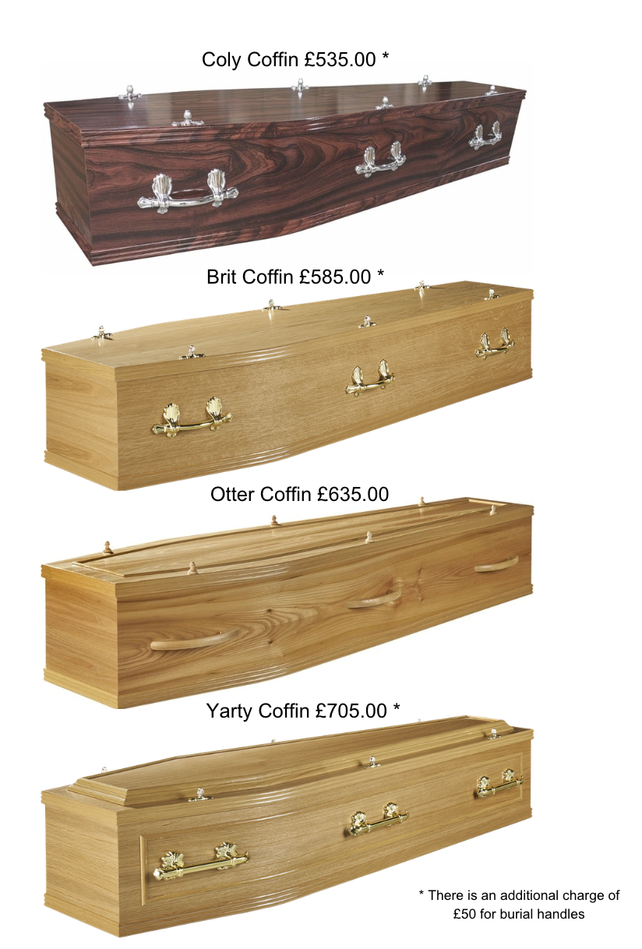

Coffin Choices

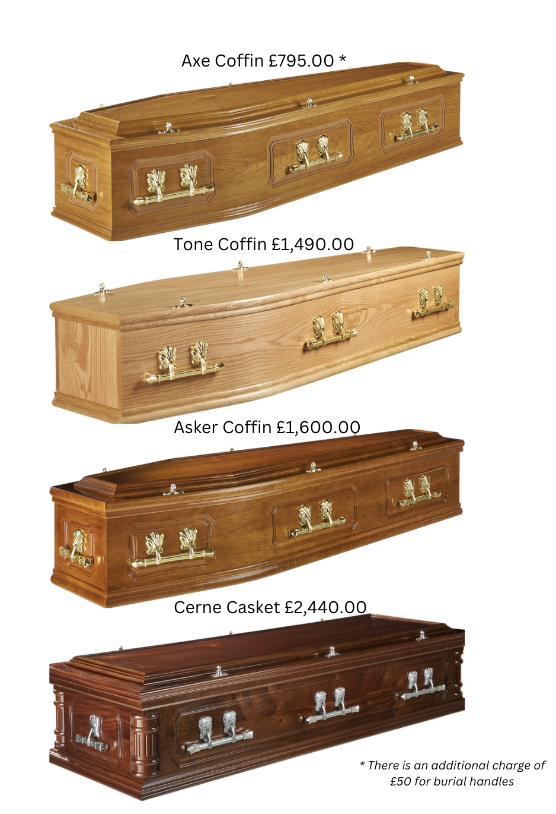

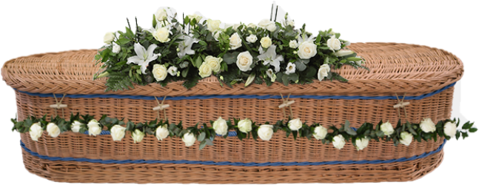
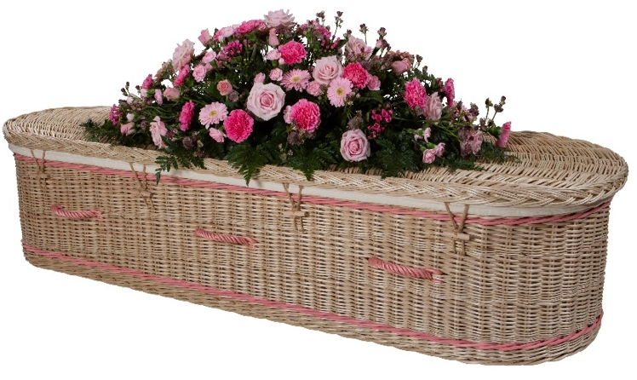
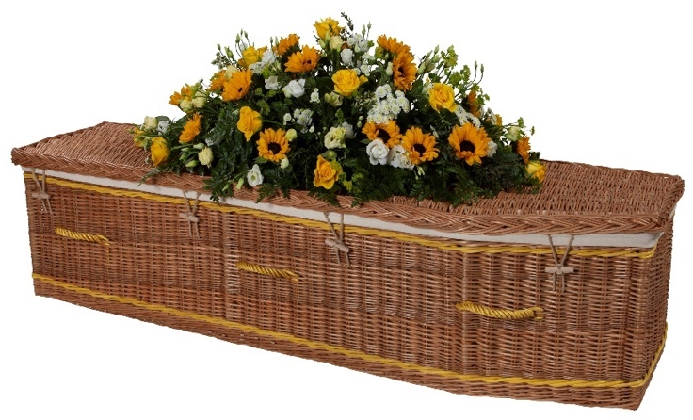
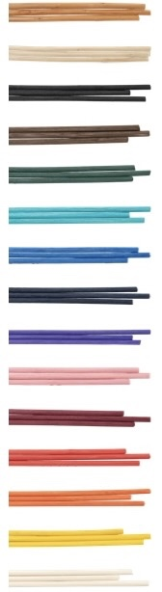
Floral Tributes priced separately
Somerset Willow Traditional Buff from £1,040.00

Colours
available
Somerset Willow Curved Ended Buff
with Blue Band from £1,040.00
Somerset Willow Curved Ended Weatherbeaten Gold
from £1,040.00
Coffin Choices
Coffin Choices
Parley Green Premium Cardboard Oak Coffin £550.00

Coffin Choices
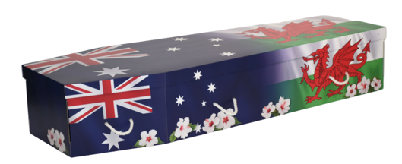
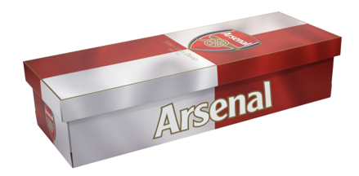
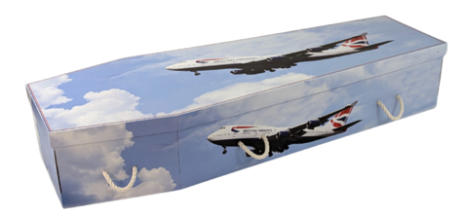
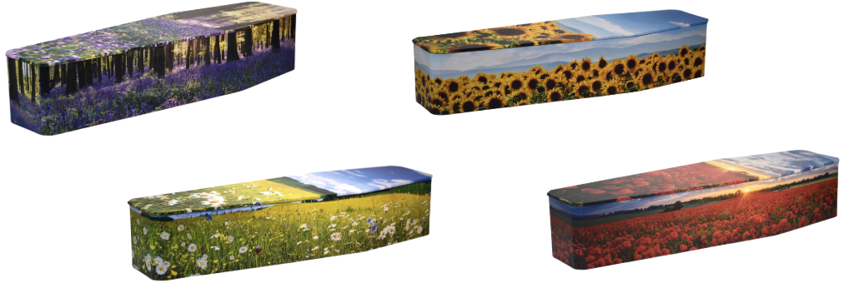
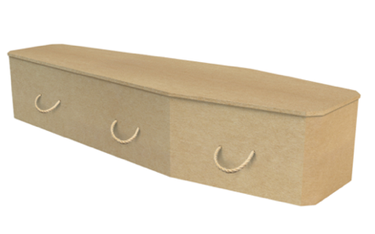
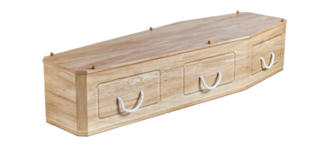
Parley Green Bespoke Cardboard Coffin
£815.00

Parley Green Floral Cardboard Coffin
£725.00

Parley Green Earthcare
Cardboard Coffin £535.00

Coffin Choices
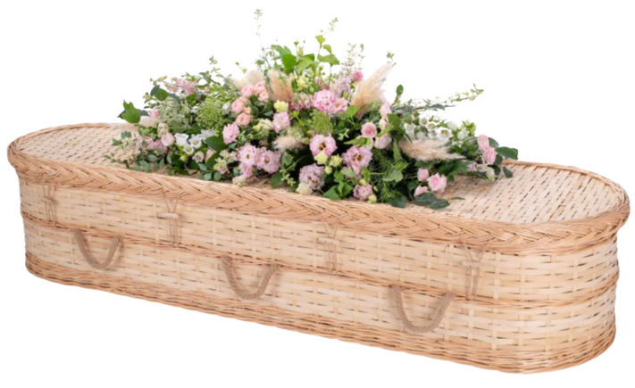
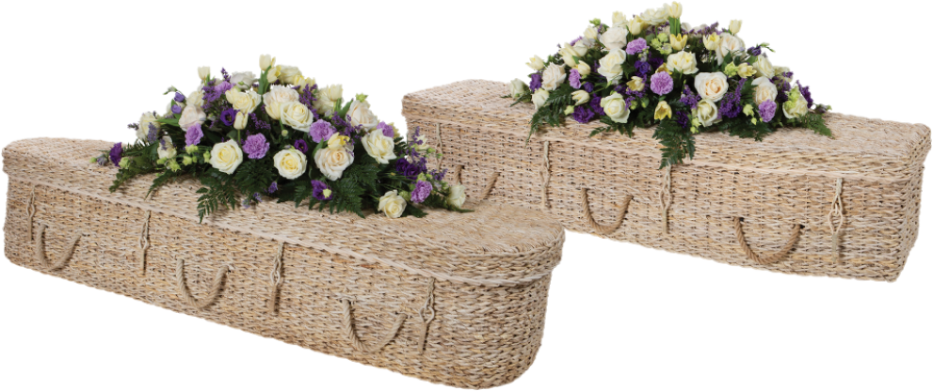
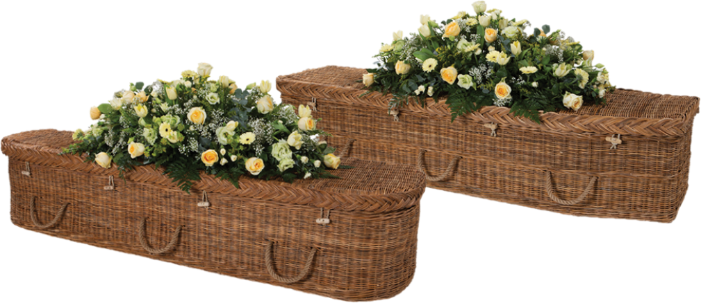
Imported – Banana Leaf Curved and Traditional shape
from £855.00
Floral Tributes priced separately
Imported – Bamboo Curved and Traditional Shape
from £855.00
Imported – Wicker Curved and Traditional Shape
from £855.00
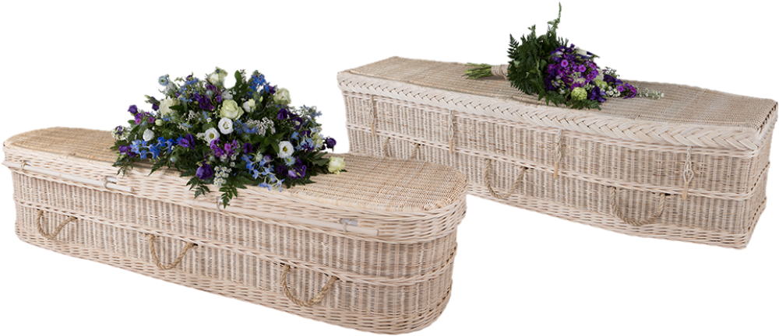
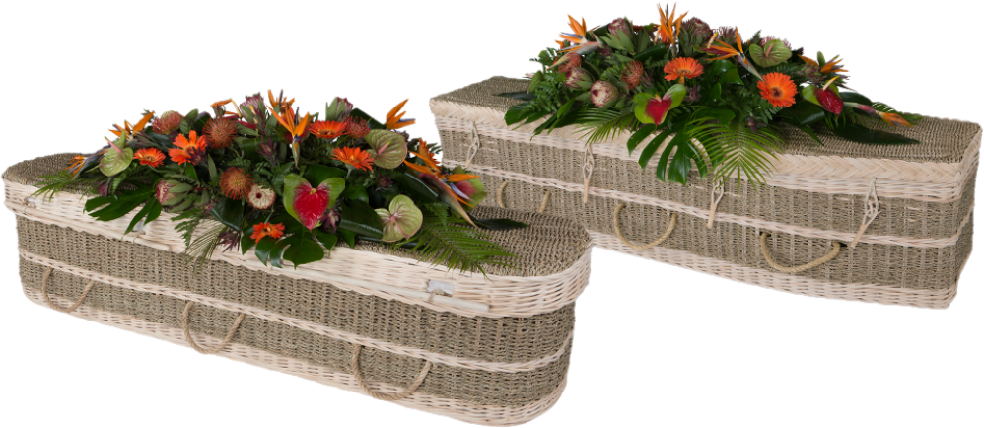
Imported – Cane Curved and Traditional Shape
from £855.00
Imported – Sea Grass Cane Curved and Traditional Shape
from £855.00
Floral Tributes priced separately
Coffin Choices
Coffin Choices
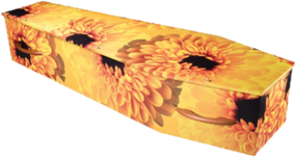
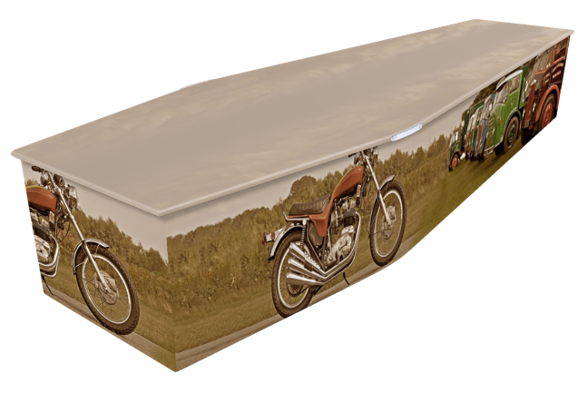
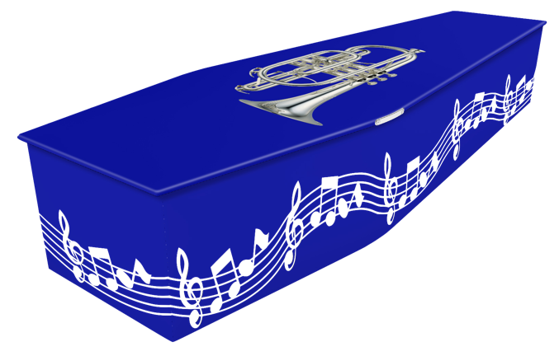

Colourful Coffins MDF Wood Veneer Picture Coffins
Stock designs £845.00 – Bespoke designs from £925.00
We have a large selection of wood picture coffins available
Matching Ashes Caskets are also available at £150.00


Oak Ashes Casket £115.00

Double Oak Ashes Casket £150.00

Cardboard Ashes Scatterer £40.00
Cardboard Ashes Scatterer Smaller and Keepsakes £30.00

Somerset Willow Ashes Caskets
Single Ashes Casket (round, square or rectangular) £125.00
Double Ashes Casket (rectangular only) £150.00

Imported Ashes Caskets
Single Ashes Casket (round or rectangular) £95.00
Wicker, Banana Leaf, Sea Grass Cane
Cocostick & Bamboo £95.00

Ashes Containers

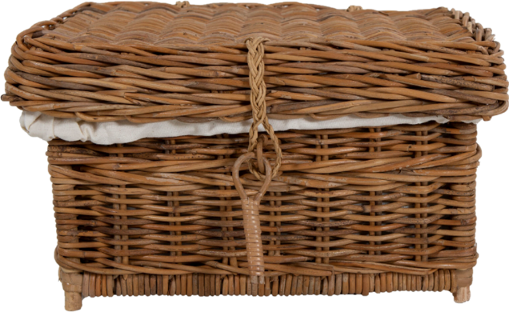

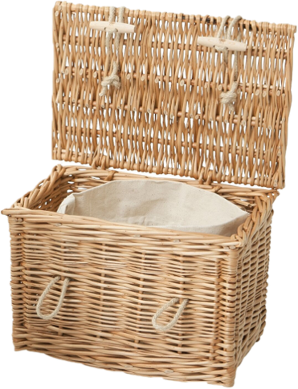
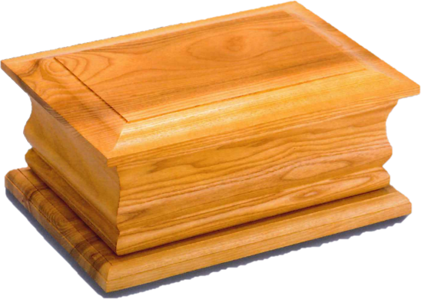
Oak Ashes Casket
Single £115.00 Double £150.00

Wicker Ashes Casket (imported)
£95.00
Willow Ashes
Urn and Casket
(Somerset)

Single £125.00
Double £150.00
Ashes Container Choices
Ashes Container Choices
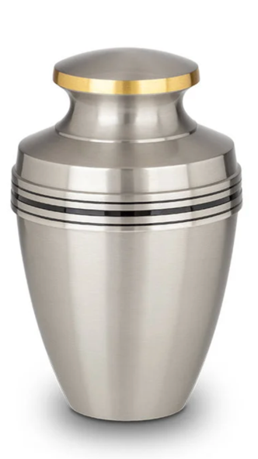

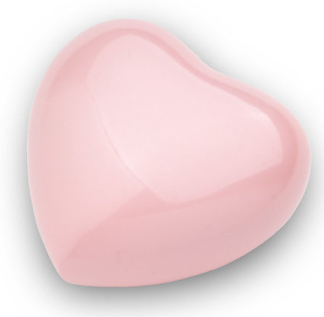
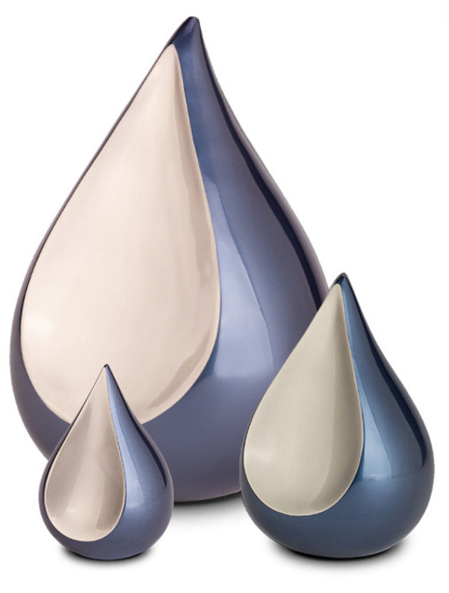
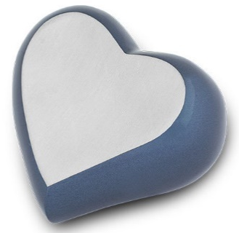
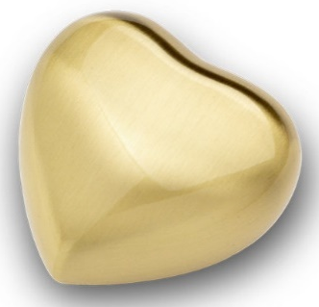
HU 182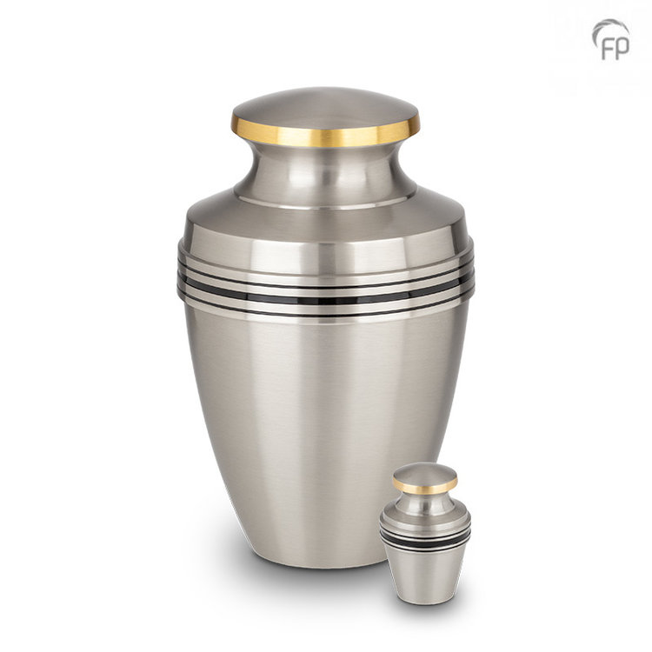
14cm high
KU 055 S
6cm high
KU 055 K
17cm high
KU 055 L
9cm high
FPU 103 K
FPU 103
26cm high
17cm high
28cm high
7cm high
HUH 409
7cm high
7cm high
HUH 007
FPU 103 S
FPU 133
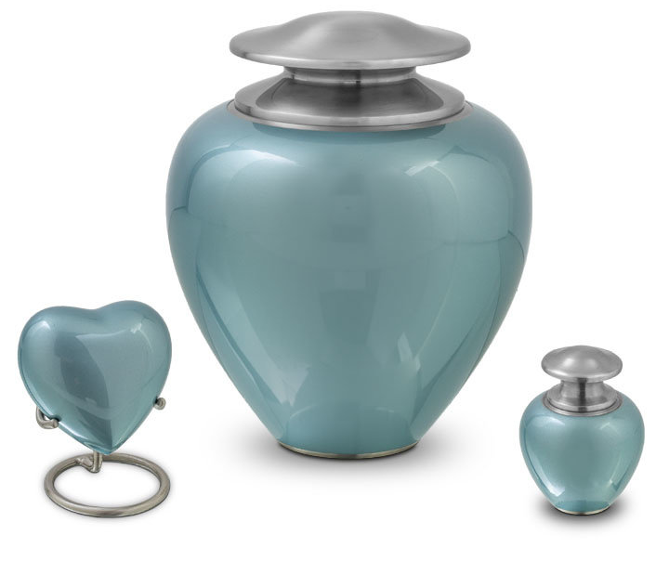
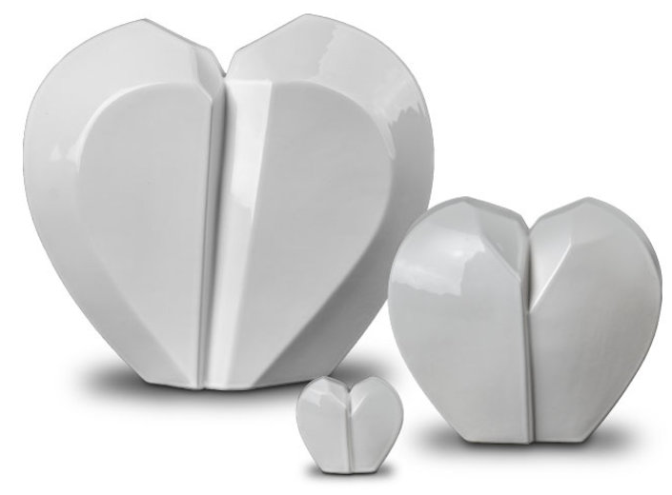
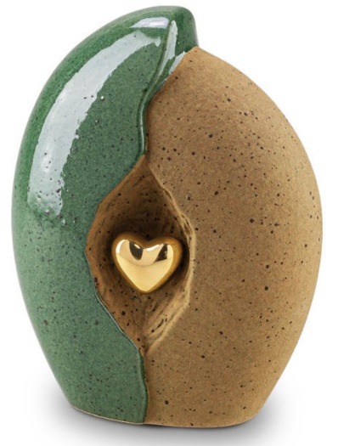
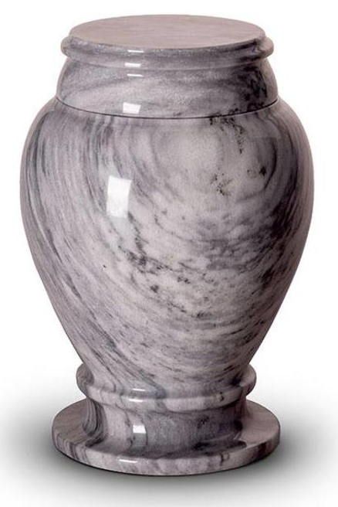
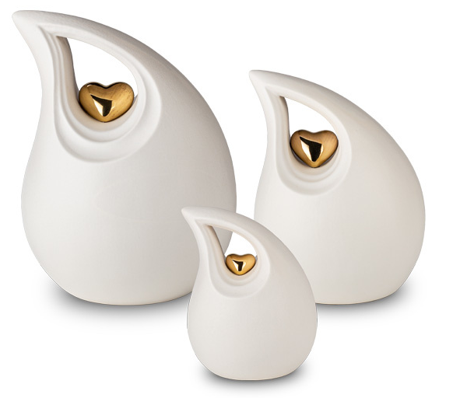
HU 407 K
7cm high
SU 6783 28cm high
29cm high
KU 003
23cm high
HU 407
HUH 407
7cm high
7cm high
KU 044 S
18cm high
27cm high
KU 044
17cm high
KU 048 S
29cm high
KU 048
22cm high
KU 048 M
KU 044 M
Ashes Container Choices
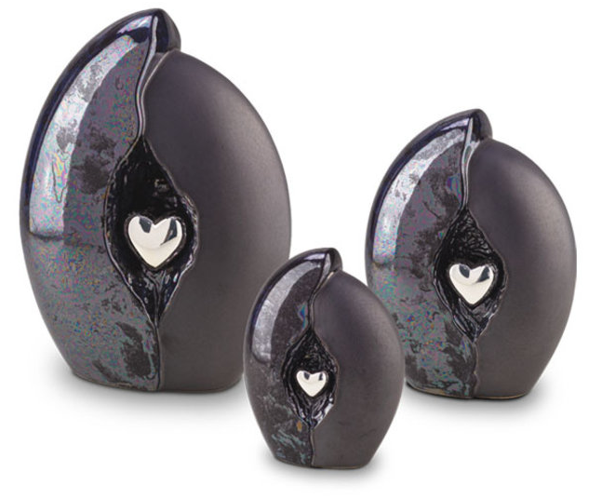
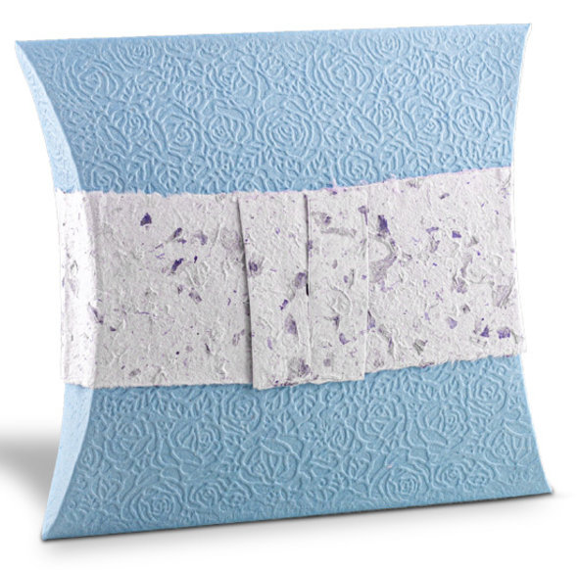
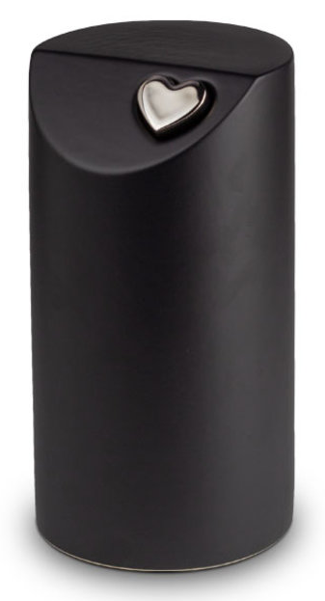
24cm high
KU 010 M
KU 010 S
17cm high
29cm high
KU 010
Water Journey Urn ZU 002 35cm high
32cm high
Ashes Container Choices
KU 106
FPU 103 £329.00
FPU 103 S £173.00
FPU 103 K £75.00
FPU 133 £77.00

HU 182 £253.00
HU 407 £77.00

HUH 007 £77.00
HUH 407 £77.00
HUH 409 £77.00

KU 003 £319.00
KU 106 £319.00
KU 010 £355.00
KU 010 M £265.00
KU 010 S £205.00
KU 044 £305.00
KU 044 S £87.00
KU 044 M £193.00
KU 048 £319.00
KU 048 M £249.00
KU 048 S £185.00
KU 055 S £177.00
KU 055 K £65.00

SU 6783 £199.00

ZU 002 £89.00

The items shown are only a small selection of what is available

Please ask your Funeral Director for a brochure or visit our website
www.funeraldirectors.uk.com
As a traditional family owned business, we are passionate about ensuring you receive the service you require at your time of need
JEWELLERY
Necklace Pendants
AH 310 £159.00
AH 085 £225.00
Necklace Chains from £67.00

Bracelet Charms
MB 002 £155.00
MB 006 £165.00
MB 008 £173.00
Bracelet Chains from £87.00

Bracelets
FPU 602 £137.00
FPU 603 £107.00
FPU 606 £117.00

Ashes Rings
EW-R-328 £255.00
EW-R-324 £240.00
EW-R-347 £260.00
Ashes Rings can be engraved

Memorial Necklace Lockets
EW-L-802 £165.00
EW-L-812 £165.00
EW-L-801 £165.00
Lockets can be engraved

Fingerprint Jewellery
EW-EN-1306 from £95.00
EW-EN-1303 from £100.00

Where applicable, prices shown are for sterling silver only
Ashes Keepsakes and Jewellery
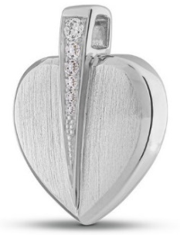
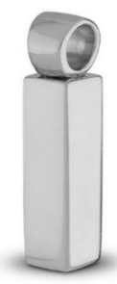
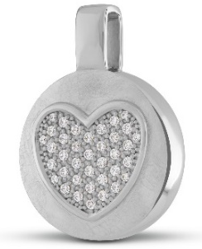
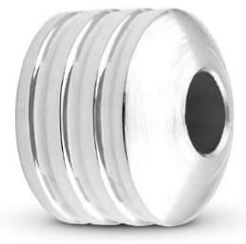
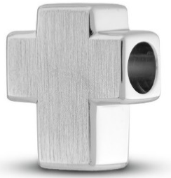
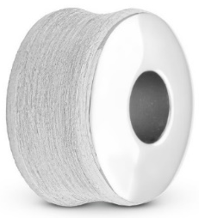
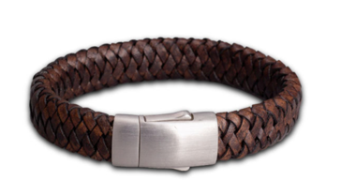
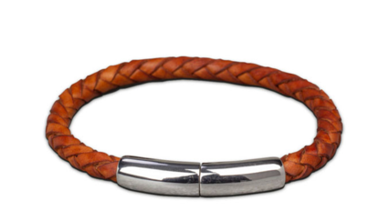
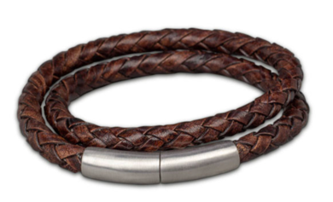
Bracelets
Bracelets Charms
Necklace Charms
AH 085
AH 310
AH 111
MB 008
MB 002
MB 006
FPU 602 FPU 603 FPU 606
A small amount of Ashes can be contained within many jewellery items
Ashes Keepsakes and Jewellery
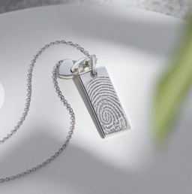
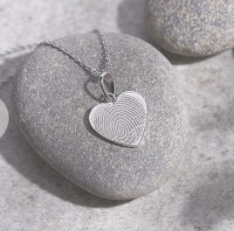
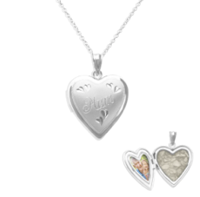
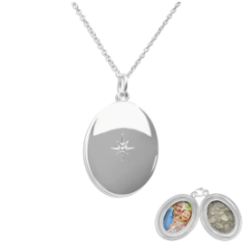
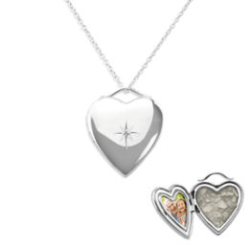
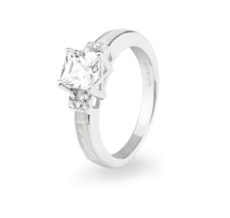
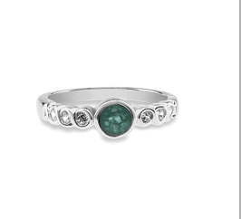
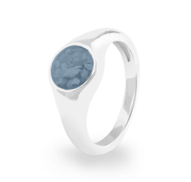
EW-EN-1306 EW-L-812 EW-EN-1303
Fingerprint Necklaces
EW-L-802 EW-L-812 EW-L-801
Memorial Necklace Lockets
EW-R-328 EW-R-324 EW-R-347
Ashes Rings
(A variety of options are available)
Ashes Keepsakes and Jewellery
The Attended Funeral
£3,025.00
plus Disbursements

The Attended Funeral includes the following:-

Taking care of all necessary legal and administrative arrangements

Collecting and transporting the deceased person from the place of death
(normally within 15 miles of the Funeral Director’s premises)
into the Funeral Director’s care, during normal working hours

Care of the deceased person before the Funeral in appropriate facilities

Provision of a Mahogany Foil Veneer Coffin

At a date and time you agree with the Funeral Director, taking the
person direct to the agreed Cemetery or Crematorium in a Hearse

A Funeral Director and four attendants

A complimentary online tribute where donations can be collected through our partnership with Muchloved

_______________________

The Attended Funeral does not include:-

Provision of a Limousine

Mileage for collection over 15 miles from the place of death

Arranging Service Sheets or Newspaper Notices

Viewing of the deceased

Any Fees or Disbursements payable on the client’s behalf

Attendance at a Service held at a separate venue

Disbursements
are charges made by third parties such as Crematoria

It is not our usual practice to ask for a deposit or payment in advance
Weekdays | Attended Service  Standard Fee | Attended Service  Reduced Fee
East Devon Crematorium  (Whipple) | £1,115  (45 minutes)  10am - 4pm | £875  (20 minutes)  9.30am only
Exeter & Devon Crematorium | £1,350  (45 minutes)  Small Chapel  10am - 3pm  Large Chapel  10.30 - 3.30pm  also at 6pm, 7pm & 8pm | 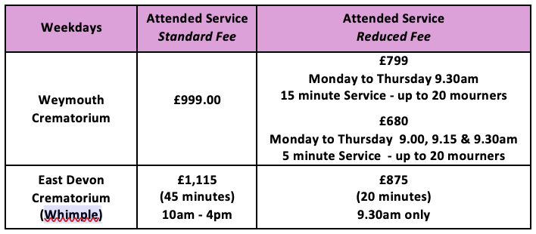  £775  (30 minutes)  Small Chapel: 8.30am, 5pm & 5.30pm  Large Chapel: 9am, 5.30pm & 6pm  £995  (60 minutes)  Small Chapel: 4pm  Large Chapel 4.30pm
Weymouth Crematorium | £999.00 | £799  Monday to Thursday 9.30am  15 minute Service - up to 20 mourners  £680  Monday to Thursday 9.00, 9.15 & 9.30am  5 minute Service - up to 20 mourners
Yeovil Crematorium | £1,100 | £499.00am & 9.30am  20 minute Service- up to 20 mourners
Disbursements for the Attended Funeral

Disbursements are payments we make on your behalf to third parties and are in addition to our Professional Charges and other fees
All Disbursements are charged at cost
(Prices correct as at 1st February 2026)
Crematoria have a Digital Music System with many types of music (including organ with and without choir backing) included in their price.
Most Crematoria have screens to show Visual Tributes (photographs and/or videos), Audio or Visual Recording and Webcasting so that a Service can be viewed by those unable to attend. They make an additional charge for the provision of these.

Because the following disbursements vary, an individual price will be given
Minister / Celebrant Church / Venue Cemetery Fees
Churchyard Fees Gravedigger Catering
Newspaper Notices Service Sheets Flowers

The Unattended Direct Funeral
where no mourners will be attending
and when no Service is to be held
£1,575.00
plus Crematorium Fee

Monday to Friday | Unattended Cremation
Weymouth Crematorium | £600

The Unattended Direct Funeral includes:-
Taking care of all necessary legal and administrative arrangements

Collecting and transporting the deceased person from the place of death
from a local address or local hospital during normal working hours

Care of the deceased person before the Funeral in appropriate facilities

Provision of a suitable Coffin

A Hearse and four attendants to attend a Crematorium of our choice
at a time chosen by us

A complimentary online tribute where donations can be collected
(if desired) through our partnership with Muchloved
_________________________

The Unattended Direct Funeral does not include:-
Collection outside normal working hours
(an additional £125.00 with be charged)

Viewing of the person who has died

A home arrangement, Embalming, Provision of a Limousine

Arranging Service Sheets or Newspaper Notices

The Administration of Offline Donations
Crematorium Fees
(Prices correct as at 1st February 2026))
Notes
v 3/26
As a traditional family owned business, we are passionate about ensuring you receive the service you require at your time of need

